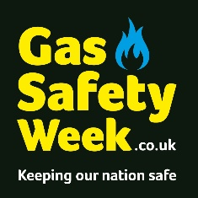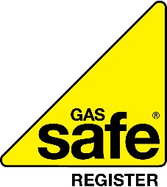

Gas Safety Week: Fighting for a Gas Safe Nation
Helping everyone stay gas safe
We are proud to be supporting Gas Safety Week 2023, taking place 11 - 17 September.
Gas Safety Week is an annual safety week to raise awareness of gas safety and the importance of taking care of your gas appliances. It is coordinated by Gas Safe Register, the official list of gas engineers who are legally allowed to work on gas.
Badly fitted and poorly serviced gas appliances can cause gas leaks, fires, explosions, and carbon monoxide (CO) poisoning. CO is a highly poisonous gas that can kill quickly and without warning, as you cannot see it, taste it, or smell it.
By taking care of your gas appliances properly and spotting the warning signs of an unsafe appliance you are taking care of your home and your loved ones. Follow these few simple steps to keep you and your family safe.
- Check for warning signs that could indicate your (or others) gas appliances are not working correctly. Signs may include lazy yellow /orange flames instead of crisp blue ones, error messages or unexpected noises from your boiler or dark and sooty stains around your gas appliance.

- Avoid blocking vents during cold spells. Vents are there to ensure your gas appliances work safely. Blocking them could prevent this.

- Never DIY on a gas appliance. If you suspect there is something wrong with your appliance or it is not working correctly, call a Gas Safe registered engineer. You can find one at GasSafeRegister.co.uk or call 0800 408 5500.

- Know the six main symptoms of carbon monoxide poisoning – headaches, dizziness, breathlessness, nausea, collapse, and loss of consciousness.

- Fit an audible carbon monoxide alarm and make sure your friends and relatives have one too. Check they are marked EN50291 and display the British Standards’ Kitemark.

- Make sure you have your annual safety check. Gas appliances should be safety checked once a year and serviced regularly by a Gas Safe registered engineer. Tenants – make sure your landlord arranges this. Set a reminder so you don’t forget at StayGasSafe.co.uk.

- Look out for your local community. You may have a friend, relative or neighbour who is unable to arrange their own gas safety check or are unaware of what they need to do to keep safe. Help them stay safe by ensuring that they have their appliances checked and serviced regularly, if they are able to do so.

- Check your engineer is qualified for the type of gas work you need doing e.g., natural gas, domestic boiler. You can find this information on the back of their Gas Safe ID card and on the Gas Safe Register website.
For gas safety advice and to find or check an engineer visit the Gas Safe Register website at GasSafeRegister.co.uk. Alternatively call the free helpline on 0800 408 5500.

